Geometry – Mrs. Taylor
Email: Rachel.Taylor@cobbk12.org
Blog: https://algebra1taylor.weebly.com
How to sign up for schoology:
1. Go to https://www.schoology.com/
2. Hover over sign-up in the upper right-hand corner and click on student
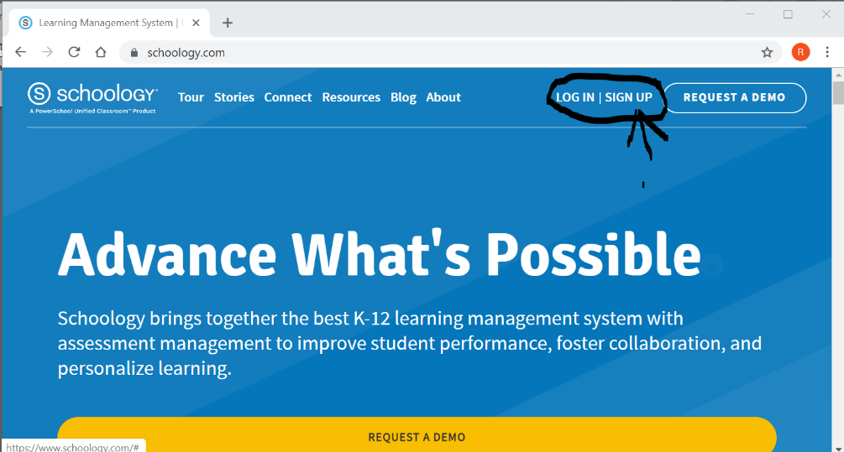

3. The page below will appear, enter my access code.
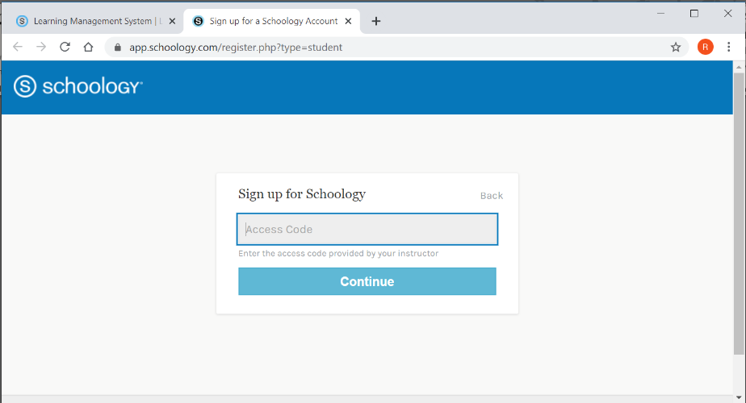

Geometry Access Code: TRR2-DZV6-FJD6T

