**Create your own Math Adventure Name:___________________________**

**Geometry Date:__________________Block:_____**

Adventure 1: Angles

Show all work for each problem you complete.

**Find the measure of all the missing angles.**

1. a=_______ 2. a =_______ b =_______ c =_______d=_______ 

If you got 1 and all of 2 correct move to question 5. If you missed any part proceed to question 3 and 4.

3. a =_______ b =_______ c =_______ 4. a =_______ b =_______ c =_______d=_______ e=_______



**Write and solve an equation to find the missing x value.**

5. x = ______ 6. X = _______

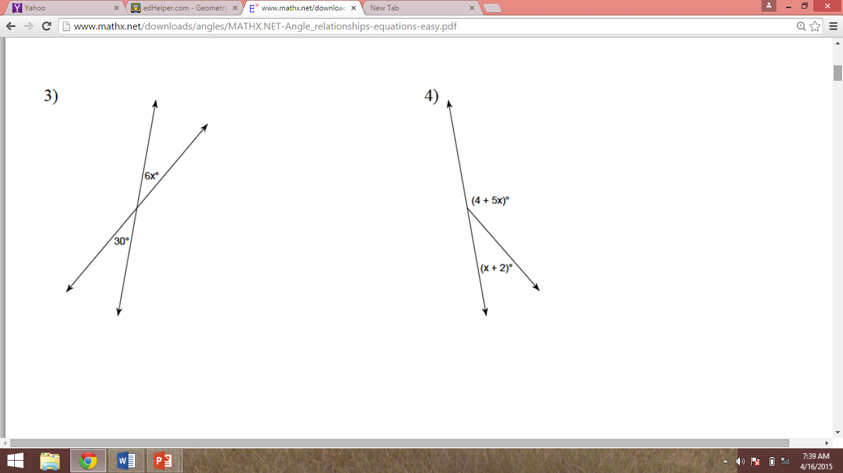

If you correctly found the value for 5 and 6 move to question 9. If not complete question 7 and 8.

**Find the value of x**

7. x = ______ 8. x = ________

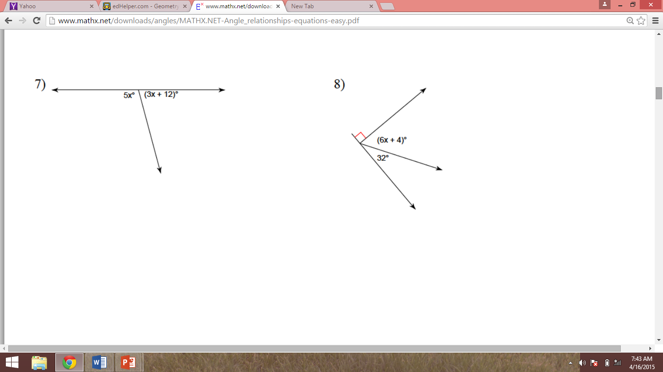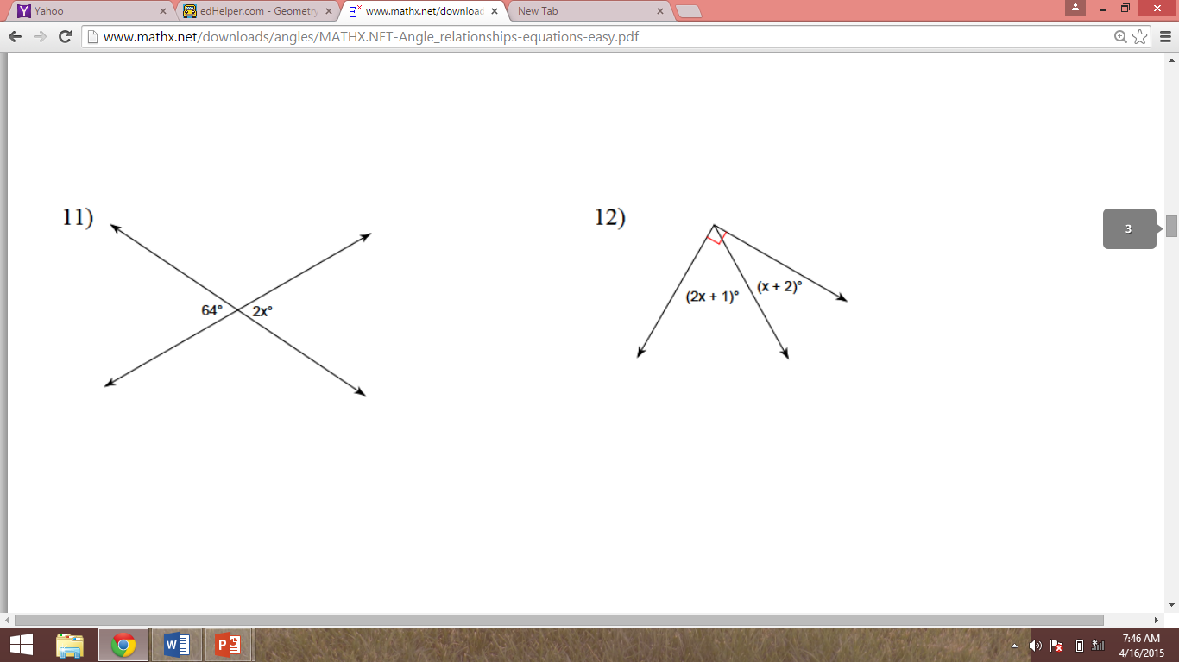

9. Find the value of x 10. Find the value of angle 6

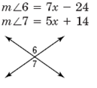

Adventure 2: Segments

Write the segment addition postulate for the points in each figure.

C

W

O

1. _____________________________

Sketch the segment described.

2. Points A, B and C are collinear with A between B and C.

If you got 1 and all of 2 correct move to question 5. If you missed any part proceed to question 3 and 4.

Write the segment addition postulate for the points in each figure.

T

N

A

3.

Sketch the segment described.

4. Points B, D and R are collinear with D outside of B and R.

Use the segment addition postulate to the length of .

43

x+4

3x+7

A

B

C

x+8

5. 6.

A

B

C

10

2x-7

If you correctly found the value for 5 and 6 move to question 8. If not complete question 7

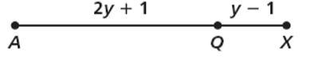7. If AX = 45, find the value of y, AQ, and QX

Draw and label an appropriate picture then solve. Show all of your work.

8. Q, A, and D are collinear with D between A and Q. If AQ = 15x -31, QD = 4x + 6, and DA = 3x -5, solve for QD.

9. B is the midpoint of AC. AB = 2x – 1 and AC = 3x+ 2. Draw the diagram.

x= AB= ___ BC = _ AC =

J

B

A

D

Z

10. Given JB is the segment bisector of AD,

AD = 24, AZ = 2x + 4, and m∠JZA= 3y,

Find the value of x and y.

1.  2. a =  b =  c=  d = 3. a =  b =  c=  4. a =  b =  c=  d = e= 5. x = 5 6. x = 29 7. x = 29 8. x = 21

9. x = 8 10. 

Segments

1.  2. 3. 

B A C

4. 5 5. x = 5 6. x = 8 7. y = 15  8. 

D B R

9. x = 4  10. x = 4 y = 30