Name _____________________________________________ Date ________________________________

**Day 4 – Intro to Proofs (Algebraic)**

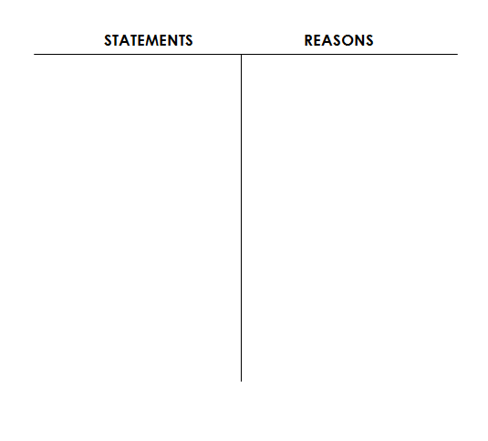

1. Given: 

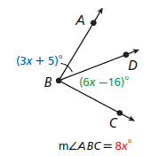

Prove: x = 11



2. Given: B is the midpoint of AC.



Prove: y = 5



3. Given: 



Prove: n = 5

4. Given: 

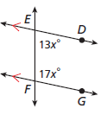

Prove: x = 6



5. Given: 

Prove: n = 60



6. Given: 



Prove: 

**Day 4 – Intro to Algebraic Proofs – Additional Practice**

7. Given: 

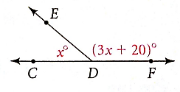

Prove: x = 40



8. Given: 

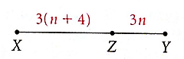

Prove: n = 5



9. Given: 

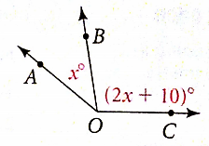

Prove: x = 43

10. Given: 

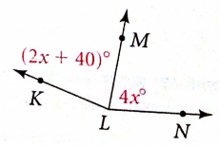

Prove: x = 20

11. Given: 



Prove: 



12. Given: 

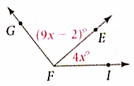

Prove: 